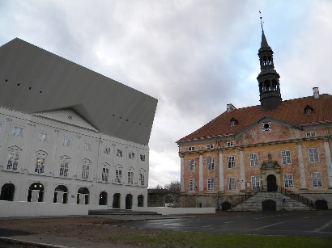 | 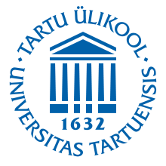 | 9th international  scientific conference  “The day of Mikael Agricola and Finnish Language”  April 9–10, 2021  (arrival: April 8)

NARVA COLLEGE OF THE UNIVERSITY OF TARTU
Raekoja plats 2, Narva 20307, Estonia
application form
Application deadline: February 15, 2021
Application should be sent to email address: conference.narva@ut.ee

Surname (in Latin script)
Given names (in Latin script)
Surname (in Cyrillic script, when possible)
Given names (in Cyrillic script, when possible)
Patronymic (отчество, for Russian names)
Professional title | 􀂅 Prof. 􀂅 Dr. 􀂅 Others (Please specify: associate professor ____________)
Personal title (not necessary to answer) | 􀂅Mr. 􀂅Ms. 􀂅Mrs. 􀂅Miss
Academic degree, level of education
Organization in original language, English and Russian (when possible)
Position
Organization address with postal code
Home page (private / institution)
Main research fields
Citizenship
Languages spoken
The city (consulate, embassy) where you will apply for a visa* DO NOT ANSWER PLEASE, IF YOU DO NOT NEED A VISA.
Date of birth*
Place of birth*
Passport number (copy of main page enclosed)*
Passport valid until*
Passport date of issue, issuing authority*
Home address (by visa application official address)
Email address @
Skype address
Primary tel: (country code – area code – tel no.) | +
Mobile phone number, which you will use in Narva (country code – area code – tel no.) | +
Fax: (country code – area code – tel no.) | +
Title of presentation (in original language)
Language of presentation
Type of presentation (oral presentation, in exceptional cases poster, audiovisual presentation via Skype)
Title of Power Point presentation (in original language)
Language of Power Point presentation
Summary (abstract, 1500–2500 characters long: author, title, text, references) please write here → (do not attach)
ACCOMMODATION AND ORGANIZED MEALS
in a single room of the hotel Inger for two nights 8th April till 10th April + organized meals for only 104,- euros. 􀂅Yes 􀂅No
2 high quality breakfasts included. 8nd April dinner (salad, main dish, dessert, coffee or tea) 19:00 (7:00 PM).
9rd April lunch (soup, main dish, dessert, coffee or tea) 14:00–15:00 (2:00 PM). 9th April dinner (salad, main dish, dessert, coffee or tea) 19:00 (7:00 PM). 10th April lunch (soup, main dish, dessert, coffee or tea) 13:00–14:00
for 2 persons in a 􀂅 double or 􀂅 twin room of the hotel Inger for 2 nights 8th April till 10th April + organized meals for only 164,- euros (for one person 82 euros).
􀂅Yes 􀂅No Name of the second person in the same room:
Date and time of arrival Please fill the date!
Date and time of departure Please fill the date!
Would you like to participate in a city excursion on 9rd April 10:00–11:45 at your expense (5 €)? | 􀂅Yes 􀂅No (Please answer “yes” or “no”!)
http://portaal.eki.ee/koik-syndmused/details/406.html
Co-organizers: Narva Ingerisoomlaste Selts (Narva), Embassy of Finland (Tallinn),
Yearbook of Finno-Ugric Studies (Iževsk, Russia)
* as per visa application

